PUBLIC HEALTH AWARENESS

1. Introduction

In this work, we aim to analyze survey data to gain insights into the spread of the diseases and associated mortality. Our study uses IBM Cognos and focuses on comparing the standard deviation and accuracy of the data. Our findings will help us understand trends, changes and potential relationships.

2. Data creation

The survey dataset was uploaded to IBM Cognos, and data cleaning was performed to check for missing values or outliers. The dataset includes information on cases and deaths.

3. Data visualization
- Comparison of mean values

Bar charts were generated to compare the number of associated cases and associated deaths in different groups (e.g. region, etc.).

- Standard deviation comparison

Box plots were used to visualize the distribution of mental health and gender , highlighting medians, quartiles, and potential extremes.

- Long-term trends

The graph was used to track trends in incidence and age of the people, allowing us to track the evolution of the epidemic.

- Communication analysis

Linear plots were constructed to examine possible relationships between population size and mortality. Correlation coefficients were calculated to quantify these relationships.

4. Research and analysis Trends

We observed significant variability in public health awareness.These changes may be due to factors such as demographics, health care, and public health policies. Correlation: Our study shows a strong positive association between population size and associated mortality. This relationship underscores the importance of timely preventive and therapeutic interventions.

1 | P a g e

PROJECT REPORT: PUBLIC AWARENESS ANALYSIS

DATA VISUALIZATION AND ANALYSIS

- Number of people attend mental health interview

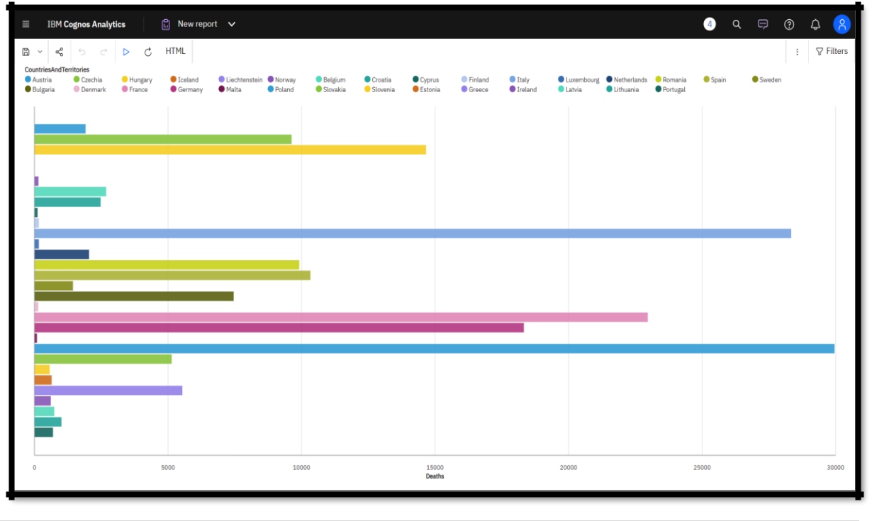

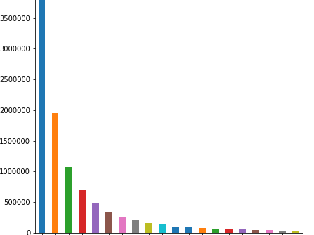

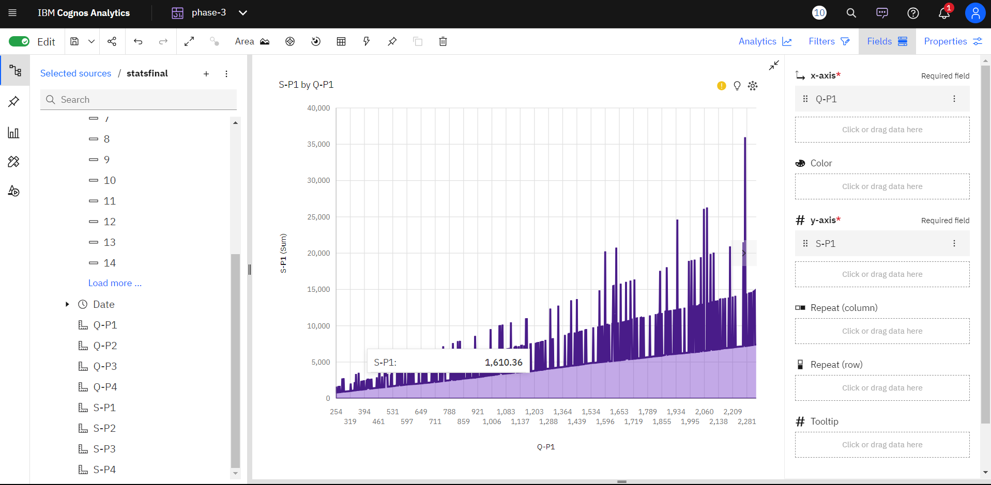

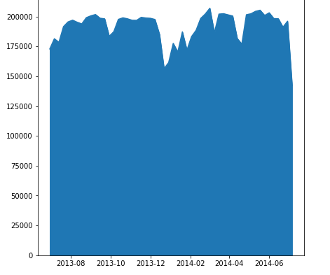

2 | P a g e

PROJECT REPORT: PUBLIC AWARENESS

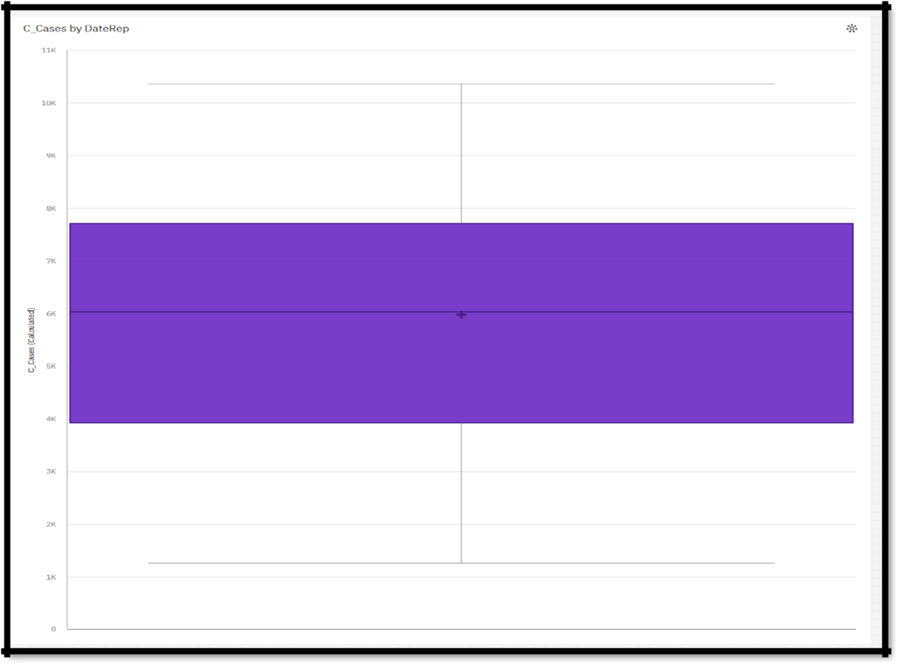

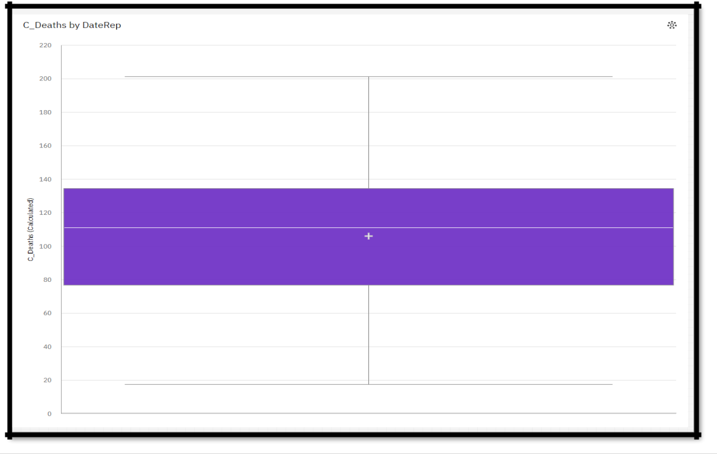

3 | P a g e
PROJECT REPORT: PUBLIC AWARENESS

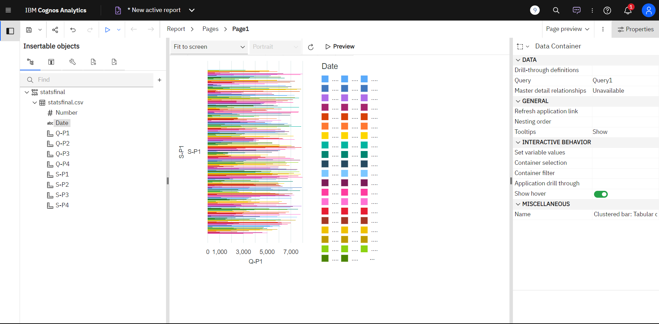

5. Conclusions

The project data analysis using IBM Cognos provided valuable insights into the Public health awareness. Trends and changes were identified, providing potential areas for targeted intervention. Correlation analysis emphasizes the importance of proactive measures to reduce the disease and save lives.

4 | P a g e

